
LEARNING AREA
Name:_________________________________________

Teacher: _______________________________________

Class: __________________________________________

CC Number: _____________________________

YEAR 8 EXAM

SEMESTER TWO 2015

SECTION TWO Resource Allowed

TIME ALLOWED FOR THIS PAPER
Reading time before commencing 3 minutes.
Working time for paper 27 minutes.

MATERIAL(S) REQUIRED / RECOMMENDED FOR THIS PAPER
TO BE PROVIDED BY THE CANDIDATE:
Standard items: pens, pencils, pencil sharpener, eraser, correction fluid, ruler, highlighters.

Special items: Calculator, 1 x A4 sheet of notes.

Important note to candidates:
No other items may be used in this section of the examination. It is your responsibility to ensure that you do not have any unauthorised notes or other items of a non-personal nature in the examination room. If you have any unauthorised material with you, hand it to the supervisor before reading any further.
TO BE PROVIDED BY THE SUPERVISOR:
This Question / Answer Booklet

Instructions to candidates
- Candidates are to remain seated during the exam and are not allowed to talk to other candidates.
- Mobile phones are not to be used at all during the exam.
- Students who fail to follow examination rules will be removed and dealt with in accordance to the schools policy.

Write your answers in the spaces provided in this Question/Answer Booklet. Spare pages are included at the end of this booklet. They can be used for planning your responses and/or as additional space if required to continue an answer.
- Planning: If you use spare pages for planning, indicate this clearly at the top of the page
- Continuing an answer: If you need the space to continue an answer, indicate in the original answer space where the answer is continued, i.e. give the page number. Fill in the number of the question(s) that you are continuing to answer at the top of the page.

Show all your working clearly. Your working should be sufficient to allow your answers to be checked readily and for marks to be awarded for reasoning. Incorrect answers given without supporting reasoning cannot be allocated any marks. For any question or part question worth more than two marks, valid working or justification is required to receive full marks. If you repeat an answer to any question, ensure that you cancel the answer you do not wish to have marked.

Use a blue or black pen only, except with diagrams where you should use pencil.

Question | Out of | Mark
1 | 3
2 | 3
3 | 3
4 | 3
5 | 4
6 | 4
7 | 5
8 | 5
TOTAL | 30
Your Mark | /30
Percentage

Question 1 [3]
Use the formula $y=-2x+2$ to complete the table of values
$$x$$ | -3 | -2 | -1 | 0 | 1 | 2 | 3
$$y$$

Question 2 [3]
Use the values from Question 1 to plot the graph on the axes provided

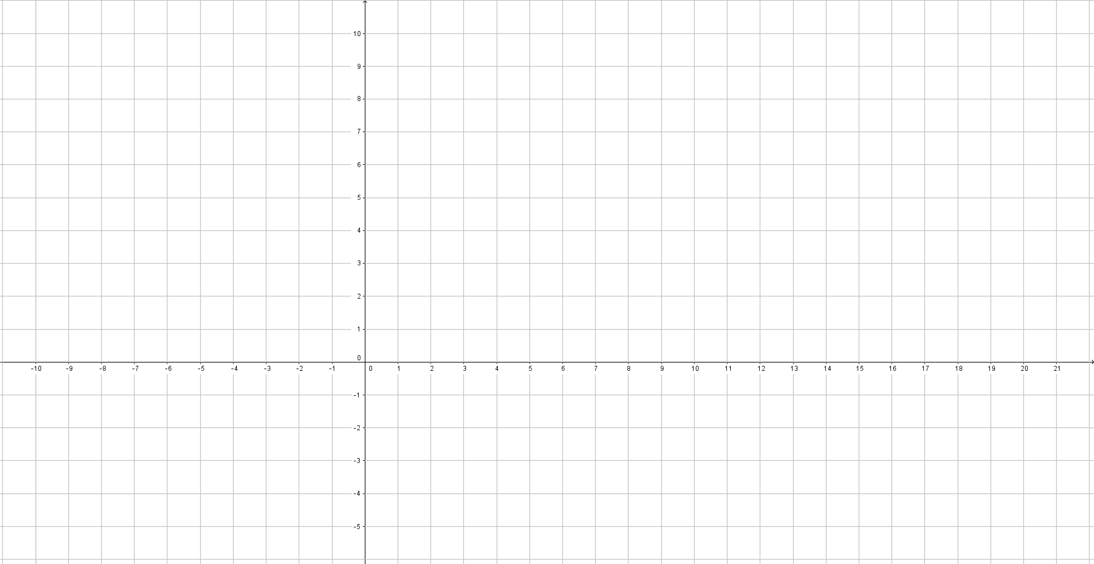

Question 3 [3]
Find the formula from the following table of values

$$x$$ | -3 | -2 | -1 | 0 | 1 | 2 | 3
$$y$$ | 4 | 3 | 2 | 1 | 0 | -1 | -2

Question 4 [3]
Find the gradient of the following graphs
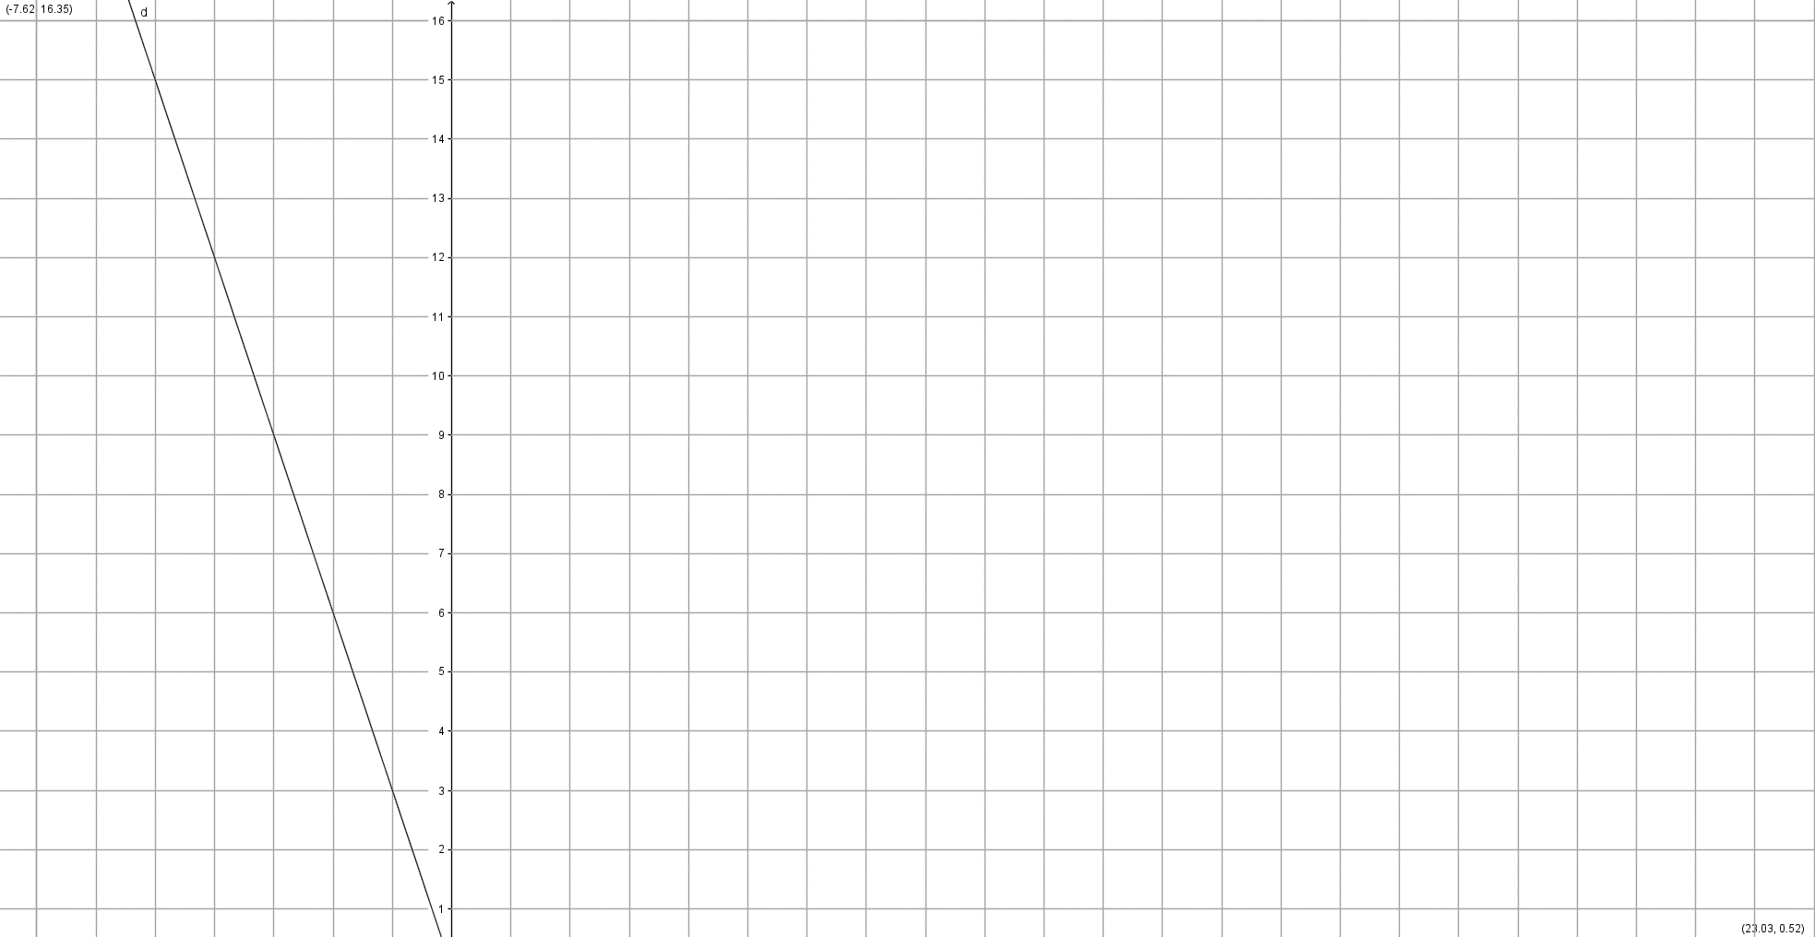
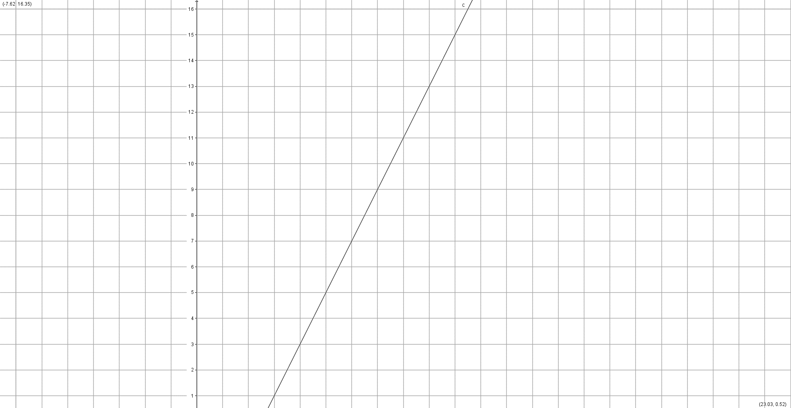
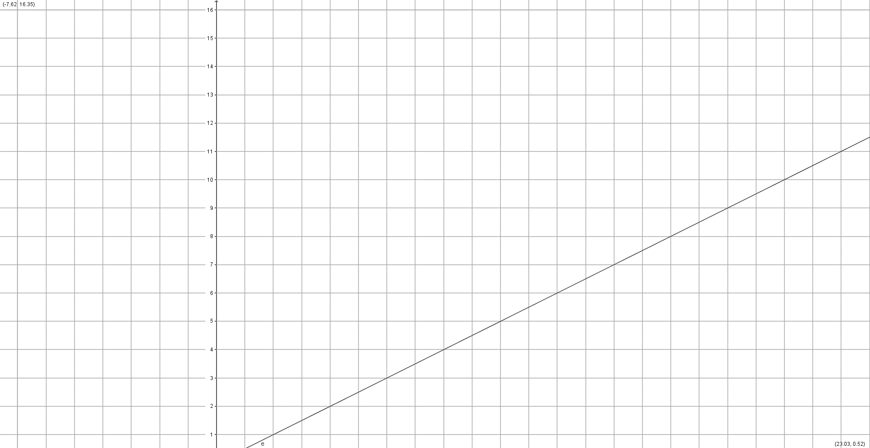
Question 5 [4]
Find the equations of the following graphs
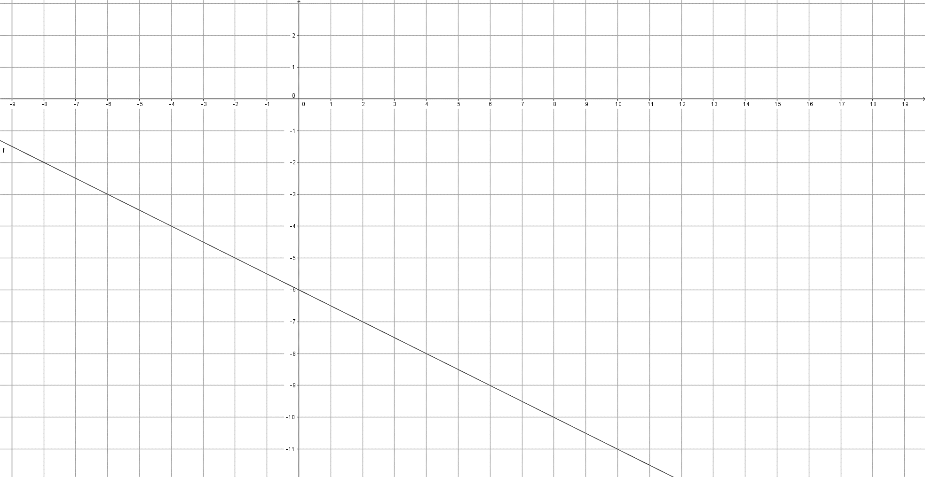

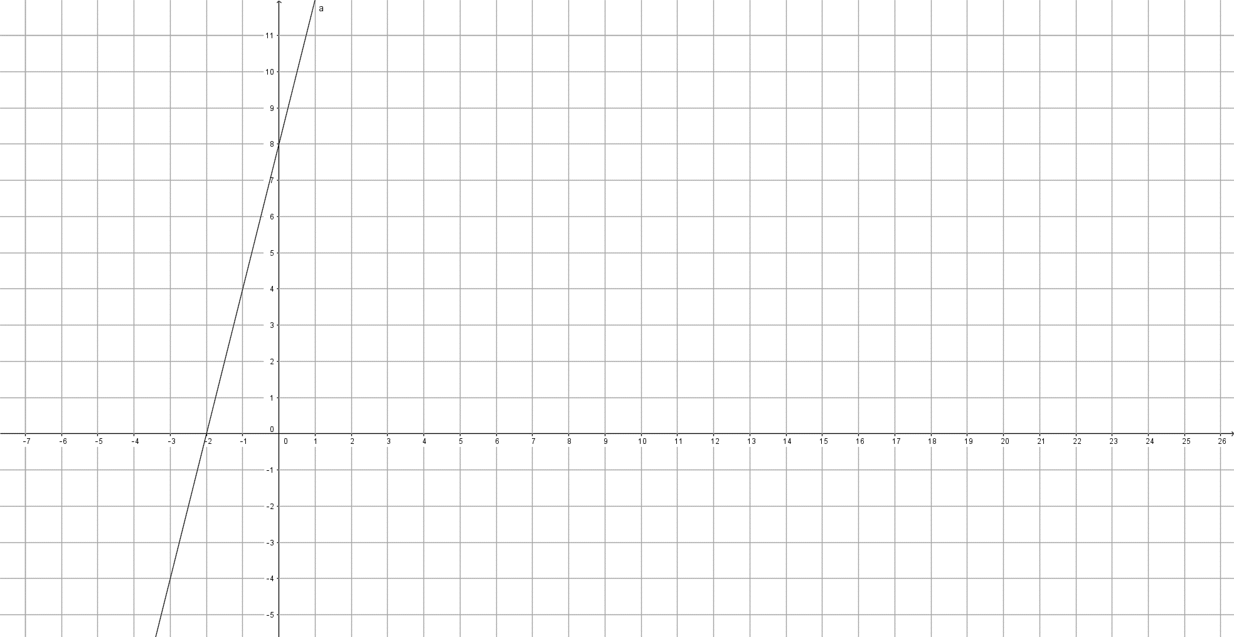

Question 6 [4]
Sketch the graphs for the following equations on the axes provided
$$y=3x+5$$
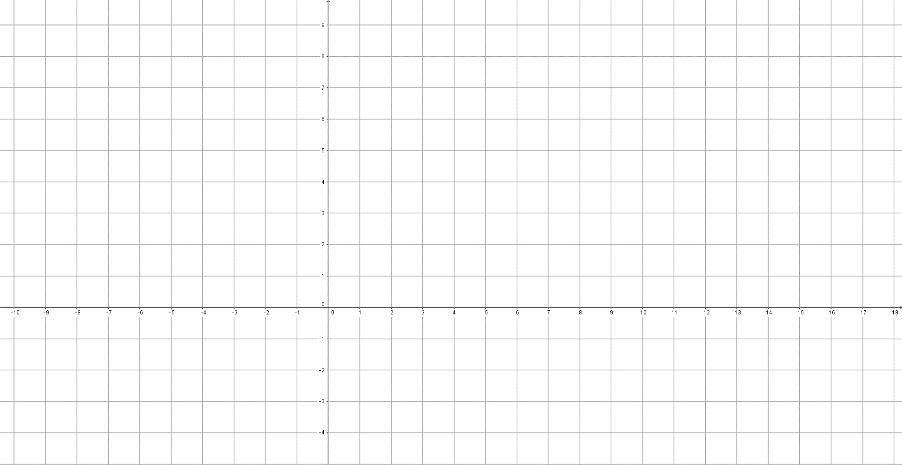
$$y=-x-2$$

Question 7 [5]
John plants a tomato seed which sprouts and grows 5mm per day in height for 7 days.
a. Complete the table of values for the height of the tomato plant
Day (d) | 0 | 1 | 2 | 4 | 5 | 7
Height (h)

b. Plot the growth of the plant on the axes provided (don’t forget to label the axes)
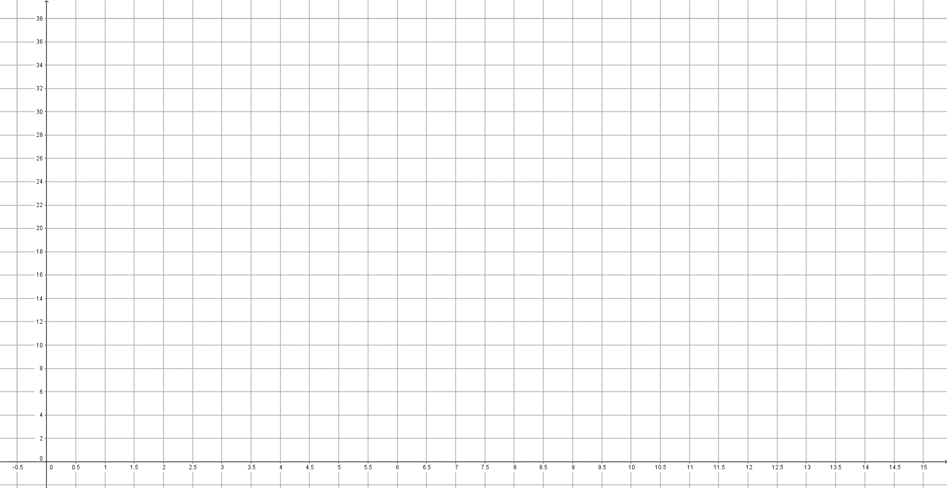

c. What is the height of the plant after 3 and a half days?

Question 8 [5]
A buoy and speed boat are 12 km apart. The boat travels at 2km per minute.

a. Construct a table of values (Hint: time goes on the $x$ axis)

b. Plot the points on the axes provided (don’t forget to label the axes)
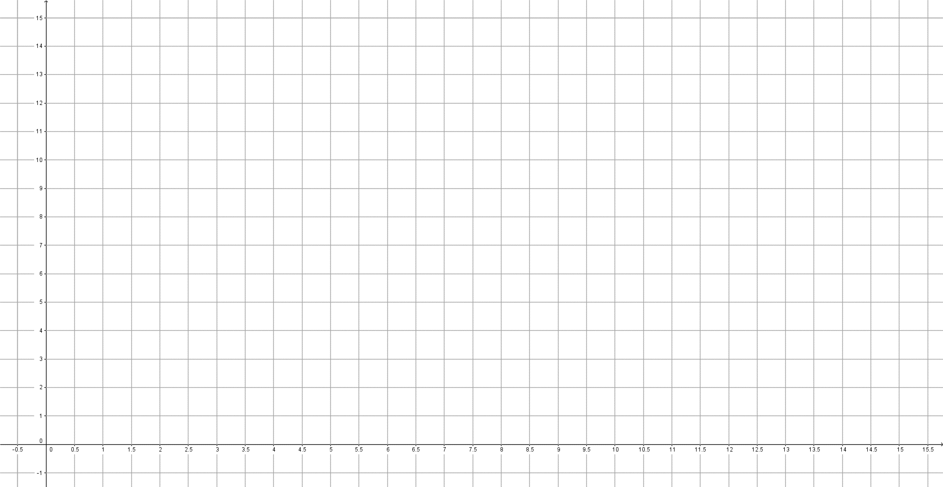

c. What is the formula for the graph?

